E-Commerce Customer & Sales Analytics
Ananya Remani
Department of Computer Science and Engineering
Koneru Lakshmaiah Education Foundation
Hyderabad, India
[2420030086@klh.edu.in]

Bingi Nageshwari
Department of Computer Science and Engineering
Koneru Lakshmaiah Education Foundation
Hyderabad, India
[2420030426@klh.edu.in]

Challapalli Harini
Department of Computer Science and Engineering
Koneru Lakshmaiah Education Foundation
Hyderabad, India
[2420030629@klh.edu.in]

Dr. N. Sunanda
Department of Computer Science and Engineering
Koneru Lakshmaiah Education Foundation
Hyderabad,India

Abstract— Modern e-commerce systems record customer transactions at a scale that makes manual interpretation difficult. This study develops an analytical framework that connects purchasing activity with customer profiling and sales-oriented visualization. Instead of treating every transaction independently, the proposed workflow converts customer histories into behavioral indicators and groups customers according to their purchasing characteristics. Annual Spending, Purchase Frequency, and Average Order Value are used to describe customer value from complementary perspectives. K-Means clustering with six groups is applied to identify behavioral patterns, followed by graphical analysis of the resulting segments. A dashboard based on Recency, Frequency, and Monetary indicators is used to communicate the analytical results. The resulting framework demonstrates how descriptive analytics and unsupervised learning can be combined to reveal differences in customer activity and support structured interpretation of e-commerce data.
Keywords—E-commerce, customer analytics, sales intelligence, behavioral profiling, K-Means, RFM, customer value, data visualization

Introduction
Digital commerce has changed the way organizations collect and use customer information. Every order contributes transaction attributes that can reveal purchasing intensity, spending capacity, and differences between customer groups. When these records are examined systematically, they can provide a foundation for understanding both customer value and sales behavior.
A difficulty arises when large transaction tables are viewed only through individual sales records. A customer who purchases many times and a customer who places a few expensive orders may generate similar revenue but represent very different behavioral patterns. Therefore, customer analytics should consider multiple dimensions rather than relying on a single sales measure.
This study focuses on the analytical relationship between customer activity and sales-related measures. The approach first prepares customer-level variables, then applies an unsupervised learning technique to discover groups with similar characteristics. Visual summaries are subsequently used to interpret the groups and communicate their practical meaning.
The objective is to construct an end-to-end analytics workflow in which transaction information is converted into measurable customer behavior, customer groups are

discovered computationally, and the resulting patterns are presented in an accessible form. The work also demonstrates how dashboard-based reporting can complement machine-learning analysis.

LITERATURE REVIEW
Research in customer analytics has increasingly moved from simple demographic profiling toward behavior-based segmentation. Transactional variables are valuable because they reflect what customers actually do rather than only describing who they are. RFM analysis is one established representation in which recent activity, purchase count, and monetary contribution are considered together.
Wu et al. [1] examined customer value identification through an improved RFM representation and K-Means++ clustering. Their work illustrates how transactional behavior can be transformed into groups that reflect different levels of customer value.
Li et al. [2] investigated RFM-weighted K-Means for e-commerce segmentation. The study emphasizes the possibility of giving different importance to behavioral dimensions when customer groups are formed.
Wu et al. [3] explored an improved K-Medoids approach for e-commerce customers. Their research demonstrates that clustering methodology can influence how customer groups are formed and interpreted.
Gomes and Meisen [4] reviewed segmentation approaches used for personalized targeting in e-commerce. The review shows that customer segmentation can support different downstream applications depending on the business context and selected customer features.
Mehta and Sehgal [5] examined micro-segmentation in retail using K-Means. Their study provides another example of using unsupervised learning to divide a heterogeneous customer population into smaller behavioral groups.

Research Gap
The reviewed studies establish the usefulness of behavioral segmentation, but the analytical process can be made more comprehensive by linking segmentation with sales interpretation and visual reporting. In particular, a workflow
that moves from customer-level feature construction to clustering, pairwise behavioral visualization, and dashboard communication provides a broader analytical perspective. This study follows that integrated direction.

PROPOSED METHODOLOGY
The proposed system treats customer analytics as a sequence of transformations. Raw e-commerce records are first organized into an analysis-ready form. Customer-level measures are then calculated, exploratory relationships are examined, and a clustering model is applied. Finally, the discovered groups are summarized through visual and dashboard-based outputs.

Data Collection
The analytical input consists of e-commerce customer and purchase information. The transaction history provides the basis for calculating customer-level indicators. Rather than focusing only on individual orders, the study aggregates purchase activity so that each customer can be represented by a consistent set of behavioral measurements.

Data Preprocessing
The preparation stage checks the input for incomplete records, repeated observations, inconsistent entries, and extreme values. Appropriate cleaning is performed before feature construction so that the clustering stage receives comparable and reliable customer records.

Exploratory Data Analysis
EDA is used to inspect the distribution of spending and purchasing activity. Summary statistics help identify differences in scale, while pairwise plots reveal whether customers with high spending also exhibit high purchase frequency or high order values. These observations provide context for interpreting the clustering output.

Customer-Level Feature Engineering
Customer profiles are represented using Annual Spending, Purchase Frequency, and Average Order Value. Annual Spending captures the overall financial contribution of a customer, Purchase Frequency captures activity intensity, and Average Order Value captures the typical size of a purchase. Using the three measures together reduces the risk of describing customers from only one perspective.
E. K-Means Customer Segmentation
K-Means assigns customer records to groups by minimizing within-cluster variation around cluster centroids. In the implemented analysis, six clusters are produced. Each cluster is subsequently summarized using its size and mean behavioral measurements, allowing the groups to be compared without relying only on individual observations..

Cluster Evaluation and Interpretation
The resulting clusters are interpreted through summary statistics and three pairwise scatter plots. The first plot compares spending with purchase frequency, the second compares spending with average order value, and the third compares frequency with average order value. This multi-view analysis helps reveal where groups overlap and where behavioral differences are more pronounced.

Interactive Dashboard Development
A customer analytics dashboard is used to translate the numerical results into a visual reporting layer. The dashboard includes RFM indicators, segment counts, an RFM score heatmap, and an insights panel. These elements provide a compact view of customer activity for interpretation and presentation..

IV. PROPOSED IMPLEMENTATION
The implementation begins with customer-level aggregation and continues through feature analysis and unsupervised learning. After the six clusters are generated, cluster statistics are calculated and visualized. The dashboard then presents a separate RFM-oriented view, allowing the analytical results to be communicated through both machine-learning and business-reporting perspectives.
The workflow used in the study is organized as: Customer Transaction Data → Cleaning and Preparation → Customer Feature Construction → Exploratory Analysis → K-Means Segmentation → Cluster Profiling → Visual Analytics Dashboard.

V. RESULTS AND OUTCOMES
The K-Means analysis generated six customer groups. The groups differ substantially in their average spending, purchase frequency, and order value. These differences show that the customer population is heterogeneous and that multiple behavioral dimensions are needed to describe it.
Cluster 0 contains 119 customers with average annual spending of 44,154.64 and average purchase frequency of 27.12. Its mean order value is 122.57. Cluster 1 is the largest group, containing 178 customers, with mean annual spending of 33,587.68 and mean order value of 203.45.
Cluster 2 records the highest average purchase frequency, at 34.40, while its mean annual spending is 45,121.93. Cluster 3 records a mean annual spending of 56,361.96 and the highest average order value, 266.78. Cluster 4 has the largest mean annual spending, 65,693.59, whereas Cluster 5 has a comparatively high spending level of 58,854.61 but the lowest purchase frequency, 13.75.
These results illustrate why customer value cannot be interpreted from revenue alone. Two groups may have relatively high spending while reaching that spending through very different purchase frequencies and order sizes.

A. Customer Segmentation Dashboard
The dashboard provides a complementary view of the customer population. It summarizes Recency, Frequency, and Monetary indicators and displays customer segments using both a distribution chart and an RFM heatmap. The insights panel highlights selected segment-level observations for easier
interpretation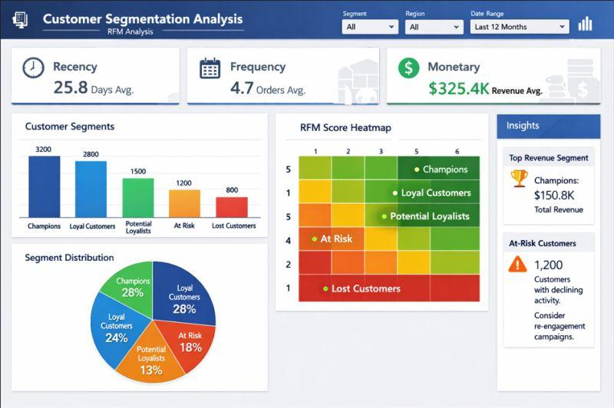
Fig. 1. Customer segmentation dashboard containing RFM indicators, segment distribution, heatmap, and analytical insights.

Cluster Visualization

The clustering figure combines the numerical cluster summary with three two-variable projections. The spending-frequency view shows how purchasing intensity varies with customer spending. The spending-order-value view highlights customers whose financial contribution is associated with larger individual orders. The frequency-order-value view provides another perspective on purchasing style.
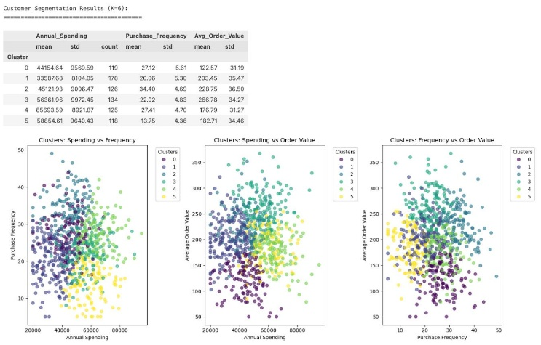
Fig. 2. K-Means customer segmentation output for K=6 with cluster statistics and pairwise behavioral plots.

C. Analytical Findings
• Customer groups differ in the combination of spending, frequency, and order value rather than following a single ranking.
• The largest cluster contains 178 customers, indicating that customer populations can be unevenly distributed across behavioral groups.
• The highest-spending cluster is not the same as the highest-frequency cluster, demonstrating the importance of multidimensional customer analysis.
• The highest average order value occurs in Cluster 3, while the highest purchase frequency occurs in Cluster 2.
• Cluster 5 demonstrates a relatively high spending level despite having the lowest mean purchase frequency, suggesting a different purchasing pattern from high-frequency customers.
• The scatter plots show partial overlap between clusters, which is expected when customer behavior varies continuously rather than forming perfectly separated categories.

CONCLUSION
The study developed a customer and sales analytics workflow for converting e-commerce transaction information into interpretable behavioral groups. The combination of
customer-level feature engineering and K-Means clustering revealed six groups with different patterns of spending, purchase frequency, and order value.
The visual analysis further demonstrated that customer value is multidimensional. The dashboard provides a separate communication layer in which RFM indicators and segment-level views can be examined together. This combination of statistical summaries, clustering, and visualization forms a practical framework for exploring customer behavior in e-commerce datasets.

FUTURE SCOPE
The framework can be extended by incorporating additional behavioral variables such as product-category diversity, discount usage, return activity, and customer lifetime value when these fields are available. Future experiments can also compare different cluster counts and alternative clustering algorithms to determine how segmentation changes under different modeling assumptions.
Further development can include demand forecasting, churn-risk analysis, personalized product recommendation, customer-level drill-down pages, and automated reporting. These extensions would connect descriptive customer analytics with predictive and prescriptive applications.
.
REFERENCES
[1] J. Wu, L. Shi, L. Yang, X. Niu, Y. Li, X. Cui, S.-B. Tsai, and Y. Zhang, “User value identification based on improved RFM model and K-means++ algorithm for complex data analysis,” Wireless Communications and Mobile Computing, vol. 2021, Art. no. 9982484, 2021, doi: 10.1155/2021/9982484.
[2] P. Li, C. Wang, J. Wu, and R. Madleňák, “An e-commerce customer segmentation method based on RFM weighted K-means,” in 2022 International Conference on Management Engineering, Software Engineering and Service Sciences (ICMSS), Wuhan, China, 2022, pp. 61–68, doi: 10.1109/ICMSS55574.2022.00017.
[3] Z. Wu, L. Jin, J. Zhao, L. Jing, and L. Chen, “Research on segmenting e-commerce customer through an improved K-Medoids clustering algorithm,” Computational Intelligence and Neuroscience, vol. 2022, Art. no. 9930613, 2022, doi: 10.1155/2022/9930613.
[4] M. A. Gomes and T. Meisen, “A review on customer segmentation methods for personalized customer targeting in e-commerce use cases,” Information Systems and e-Business Management, vol. 21, no. 3, pp. 527–570, 2023, doi: 10.1007/s10257-023-00640-4.
[5] D. Mehta and S. Sehgal, “A study on micro-segmentation of retail customers using K-means clustering,”
Journal of Business Thought, vol. 15, pp. 75–87, 2024, doi: 10.18311/jbt/2024/44468.

